

 Know Your TX – Dissecting a Transaction

**Objective/Aim:**  
  
 to understand how a transaction take place in blockchain

**Apparatus/Software Used:**

* Laptop
* Brave
* Ethereum sepolia faucet
* Metamask Sepolia testnet wallet

**Theory/Concept:**

**What Is a Blockchain Transaction (TX)?**

A transaction (TX) is a record of data change on a blockchain. Usually, this means:

* Sending cryptocurrency from one wallet to another.
* Interacting with a smart contract.
* Minting an NFT, swapping tokens, voting in a DAO, etc.



**Procedure:**

|  |  |  |  |
| --- | --- | --- | --- |
|  |  |  |  |
|  |  |  |  |
|  |  |  |  |
|  |  |  |  |
|  |  |  |  |
|  |  |  |  |
|  |  |  |  |

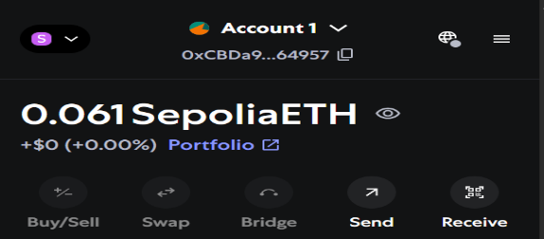**Step 1: Open your Sepolia Ethereum wallet**

**Step 2: Then go to Google Cloud Ethereum Sopelia faucet**

**Step 3: Copy paste your sopelia Ethereum account number and Receive 0.05 Sopelia ETH within few minute**

**Step 4: Open ETHERSCAN for view the transation made in your account**

**Step 5: Search your account number it will show all the transaction details** 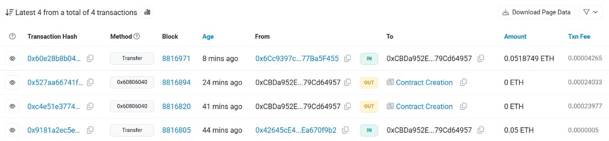

**Observation Table:**

1.Wallet address copied and pasted on Sepolia Test Network.

2.ETH requested successfully.

3.Sepolia ETH received in MetaMask wallet after a few minutes.

4.Transaction verified on Sepolia Etherscan with successful status.

